USER DEFINE FUNCTION :

CODE :

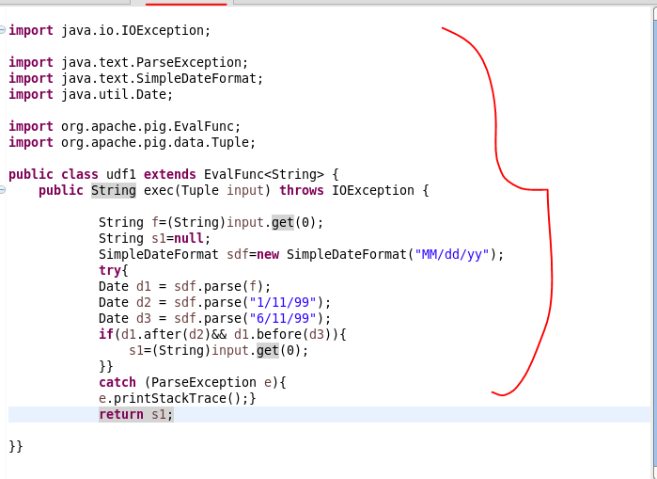

PIG COMMANDS:

C:\Users\612926\Desktop\5.PNG

LOAD command.

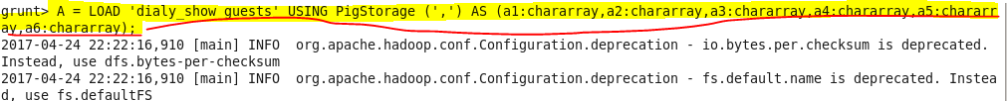

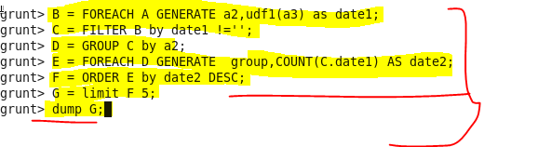

OUTPUT :

